|  |
| --- |
| **Matt Gammon Biography** |

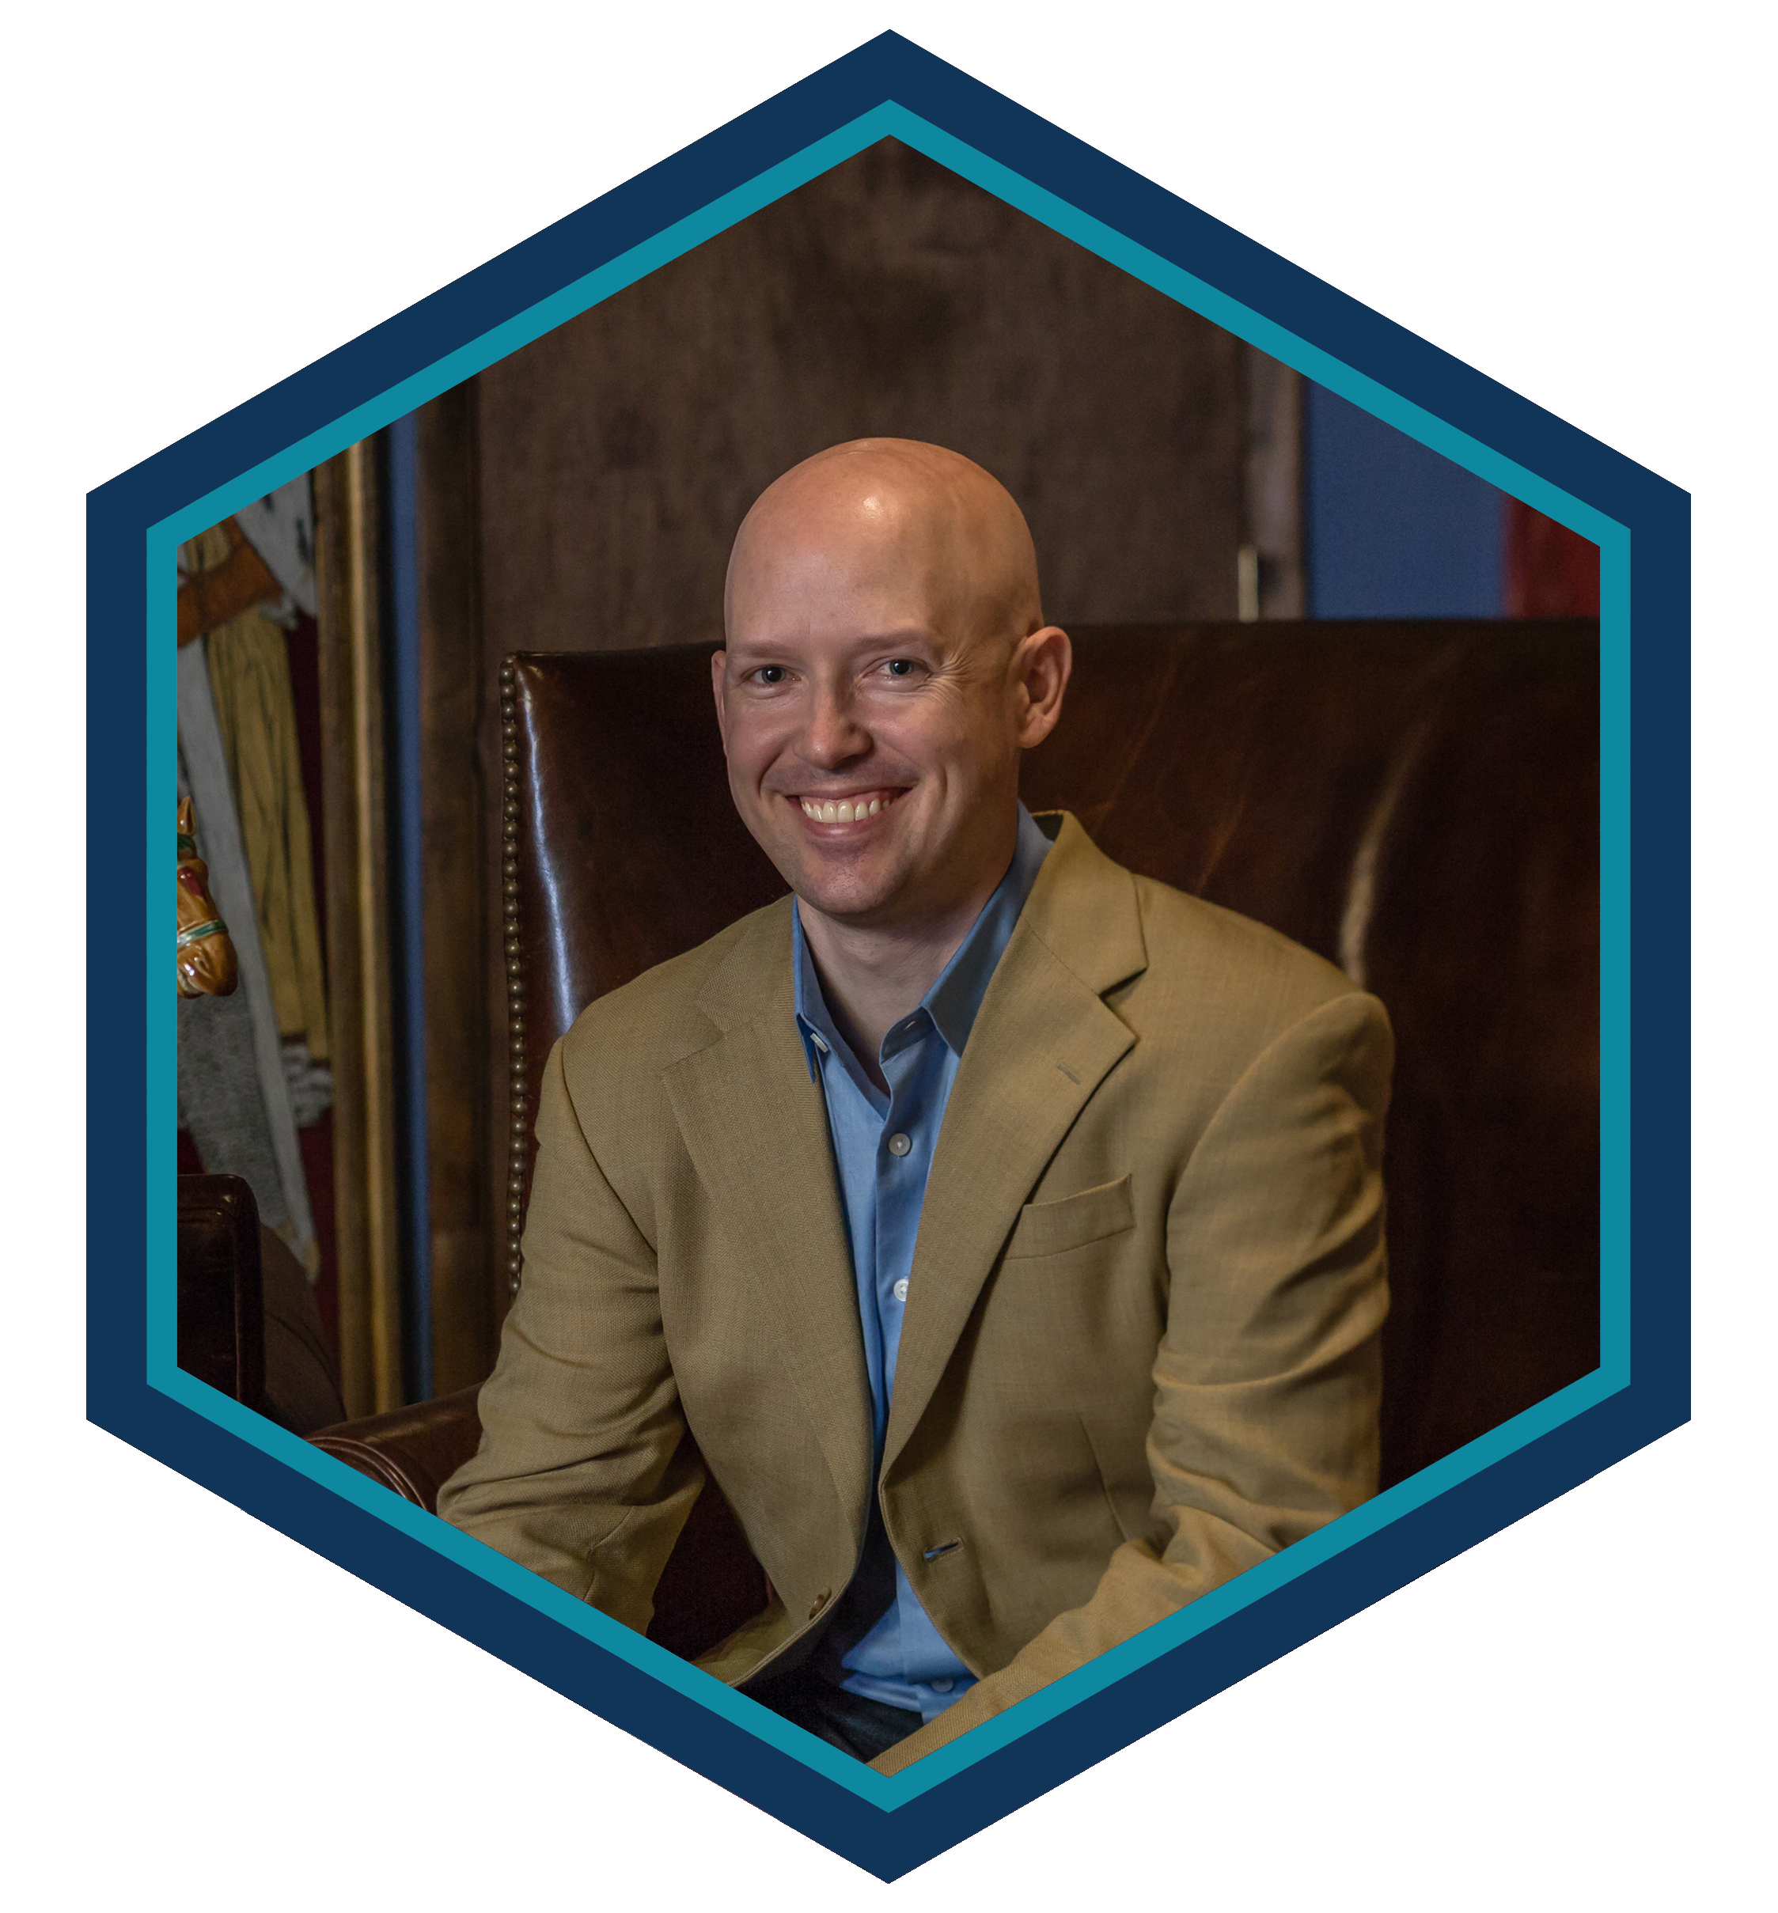

### Matt Gammon – Partner

Matt combines years of experience in profit and cash flow driven management operations with an extensive background in survey research. This combination enables him to understand the needs of decision makers in companies of all sizes. Matt works with Ragnar’s corporate and non-profit clients to develop effective strategies for branding, issue advocacy, and campaigns of all sizes.

For non-profit and association clients, Matt brings a sophisticated approach incorporating behavioral science to develop successful donor bases and position the organization as strongly as possible for future growth.

A superb project manager, Matt has managed hundreds of successful projects for non-profit, association, political, and corporate clients, including several Fortune 500 companies.   
Additionally he has done work across Europe, South America,   
and Asia on behalf of a wide variety of clients.